

CAPSTONE PROJECT REPORT
Report 4 – Software Design Document

– Hanoi, August 2019 –

Table of Contents
I. Record of Changes 3
II. Software Design Document 4
1. System Design 4
1.1 System Architecture 4
1.2 Package Diagram 4
2. Database Design 4
3. Detailed Design 5
3.1 <Feature/Function Name1> 5
3.2 <Feature/Function Name2> 6

I. Record of Changes
Date | A*  M, D | In charge | Change Description
*A - Added M - Modified D - Deleted

II. Software Design Document

1. System Design

1.1 System Architecture
[The content of this section includes the overall diagram which includes the sub-systems, the external systems, and the relationship/connection among them. You need also provide the explanation for each of the diagram components (modules, sub-systems, external systems, etc.)].

1.2 Package Diagram
[Provide the package diagram for each sub-system. The content of this section includes overall package diagram(s) and the explanation for each package (or namespace). Please see the sample and description table format below]
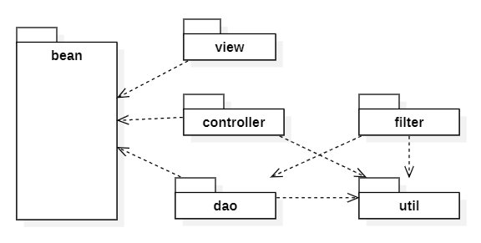
Package Descriptions
No | Package | Description
01 | <Package name> | <Description of the package>
02

2. Database Design
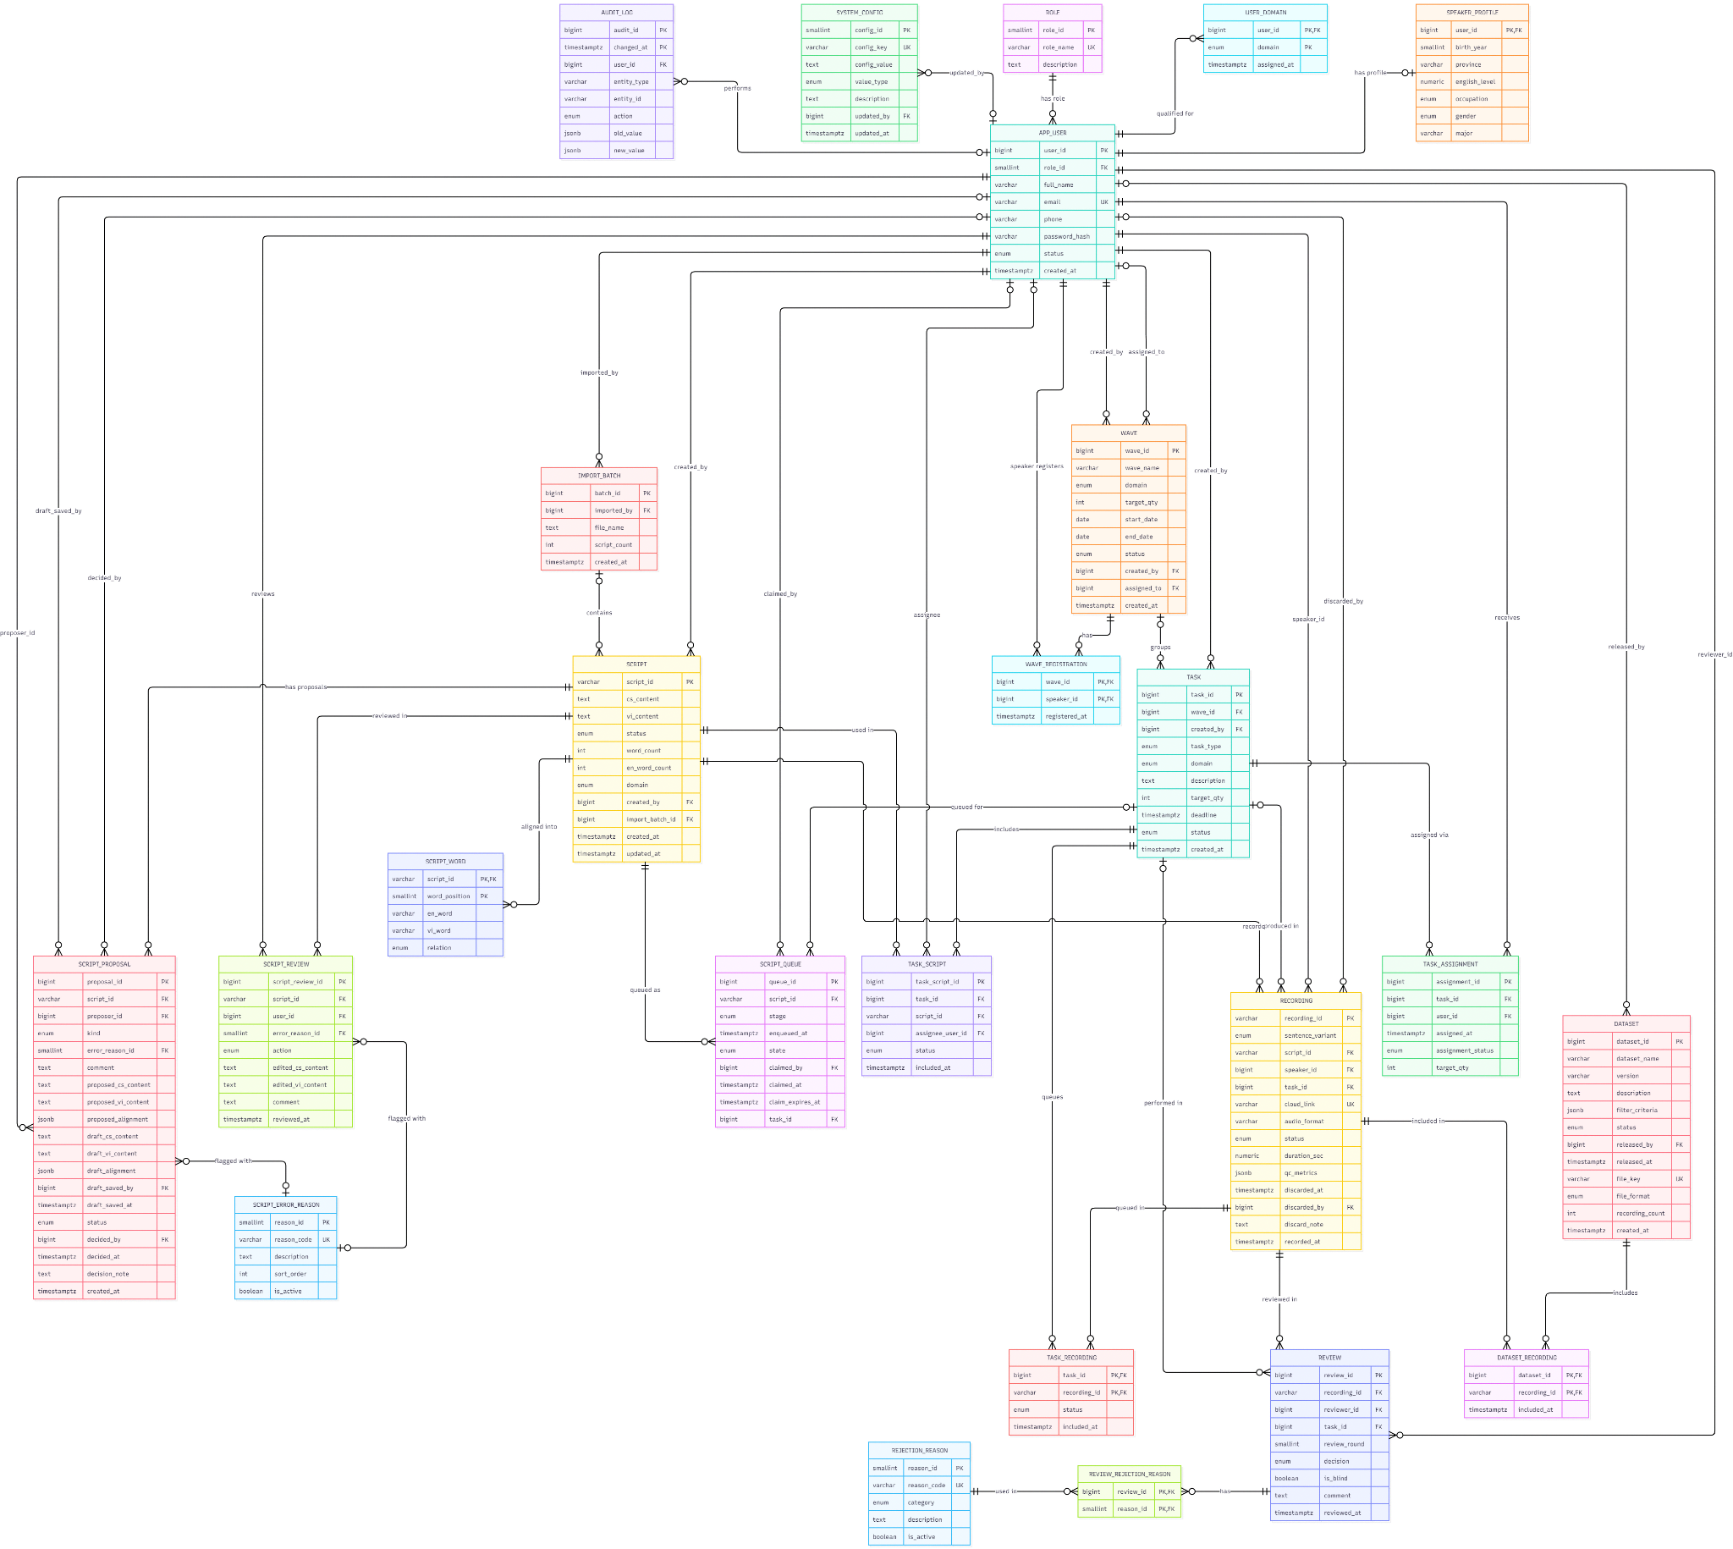
https://drive.google.com/file/d/1_KVlacUHBRGpQOEaUELSH3dvR6YBhQiw/view?usp=sharing

Table Descriptions
No | Table | Description
01 | ROLE | Lookup of system roles (speaker, reviewer, task_manager, admin) with a unique role name and description.  - Primary keys: role_id.  - Foreign keys: none.
02 | APP_USER | Account of every user: full name, unique email, phone, bcrypt password hash, status (active / inactive / suspended) and creation time. Each user has exactly one role.  - Primary keys: user_id.  - Foreign keys: role_id → ROLE.
03 | SPEAKER_PROFILE | Demographic profile of a speaker (birth year, province, English level as IELTS band, occupation, gender, major). One optional profile per user.  - Primary keys: user_id.  - Foreign keys: user_id → APP_USER.
04 | USER_DOMAIN | Topic domains (it_technology, education, daily_life) a reviewer is qualified to validate, with the assignment time.  - Primary keys: user_id, domain.  - Foreign keys: user_id → APP_USER.
05 | SYSTEM_CONFIG | Key–value system settings (review criteria, quality thresholds, queue and batch settings) with unique key, value type, description, last updater and update time.  - Primary keys: config_id.  - Foreign keys: updated_by → APP_USER.
06 | AUDIT_LOG | Change history of entities: who did what (entity type, entity id, action) with old/new values as JSONB. Partitioned monthly by changed_at, hence the composite key.  - Primary keys: audit_id, changed_at.  - Foreign keys: user_id → APP_USER.
07 | IMPORT_BATCH | One bulk import of scripts: file name, number of sentence pairs imported, importer and creation time.  - Primary keys: batch_id.  - Foreign keys: imported_by → APP_USER.
08 | SCRIPT | A sentence pair in the text corpus: code-switching content and pure-Vietnamese content, status, domain, total and English word counts, creator and optional import batch. Natural key s_ + digits that encode English-word count, domain and relation type.  - Primary keys: script_id.  - Foreign keys: created_by → APP_USER; import_batch_id → IMPORT_BATCH.
09 | SCRIPT_WORD | One row per embedded English word of a script: the English word, its Vietnamese counterpart and the relation (semantic_equivalent or proper_noun), by word position.  - Primary keys: script_id, word_position.  - Foreign keys: script_id → SCRIPT.
10 | SCRIPT_ERROR_REASON | Lookup of reasons for flagging a script (unique code, description, sort order, active flag).  - Primary keys: reason_id.  - Foreign keys: none.
11 | SCRIPT_REVIEW | A user's text-review action on a script (accepted / edited / rejected) with optional edited Vietnamese and code-switching content, optional error reason, comment and time.  - Primary keys: script_review_id.  - Foreign keys: script_id → SCRIPT; user_id → APP_USER; error_reason_id → SCRIPT_ERROR_REASON.
12 | SCRIPT_PROPOSAL | A speaker's report or edit proposal on a validated script. Also holds the reviewer's saved draft and the final decision (status, decider, time, note). At most one pending proposal per script.  - Primary keys: proposal_id.  - Foreign keys: script_id → SCRIPT; proposer_id, draft_saved_by, decided_by → APP_USER; error_reason_id → SCRIPT_ERROR_REASON.
13 | SCRIPT_QUEUE | Shared work queue of scripts per stage (text_review, recording) and state (queued, claimed, done, dropped), with FIFO time, claim owner, claim time and claim expiry so users can work concurrently without overlap.  - Primary keys: queue_id.  - Foreign keys: script_id → SCRIPT; claimed_by → APP_USER; task_id → TASK.
14 | WAVE | A collection wave: the planning unit created for a collection period, with name, single domain, target quantity, start/end dates, status (open / in_progress / completed), creator and assigned task manager.  - Primary keys: wave_id.  - Foreign keys: created_by, assigned_to → APP_USER.
15 | WAVE_REGISTRATION | Registration of a speaker to a wave (many-to-many between WAVE and APP_USER), with registration time.  - Primary keys: wave_id, speaker_id.  - Foreign keys: wave_id → WAVE; speaker_id → APP_USER.
16 | TASK | A unit of work (recording or review) with domain, description, target quantity, deadline and status, optionally grouped under a wave. A task in a wave must match the wave's domain.  - Primary keys: task_id.  - Foreign keys: wave_id → WAVE; created_by → APP_USER.
17 | TASK_ASSIGNMENT | Assignment of a task to a user, with per-user target quantity, assignment status (active, completed, reassigned, cancelled) and assignment time.  - Primary keys: assignment_id.  - Foreign keys: task_id → TASK; user_id → APP_USER.
18 | TASK_SCRIPT | Scripts included in a recording task, with status and an optional assignee speaker. Uses a surrogate key so several speakers can share one script.  - Primary keys: task_script_id.  - Foreign keys: task_id → TASK; script_id → SCRIPT; assignee_user_id → APP_USER.
19 | TASK_RECORDING | Recordings queued in a review task, with status (queued, reviewed, skipped) and inclusion time.  - Primary keys: task_id, recording_id.  - Foreign keys: task_id → TASK; recording_id → RECORDING.
20 | RECORDING | An audio recording of one sentence variant of a script by a speaker. Natural key r_cs_/r_vi_ + digits. Stores unique cloud link, audio format, duration, status, QC metrics as JSONB, and discard information (time, by whom, note).  - Primary keys: recording_id.  - Foreign keys: script_id → SCRIPT; speaker_id, discarded_by → APP_USER; task_id → TASK.
21 | REJECTION_REASON | Lookup of reasons for rejecting a recording: unique code, category (content, audio_quality, pronunciation, other), description and active flag.  - Primary keys: reason_id.  - Foreign keys: none.
22 | REVIEW | A reviewer's decision on a recording: review round, decision, blind-review flag, comment and time. One reviewer per round, and the same reviewer cannot review a recording twice.  - Primary keys: review_id.  - Foreign keys: recording_id → RECORDING; reviewer_id → APP_USER; task_id → TASK.
23 | REVIEW_REJECTION_REASON | Links a review to one or more rejection reasons (many-to-many between REVIEW and REJECTION_REASON).  - Primary keys: review_id, reason_id.  - Foreign keys: review_id → REVIEW; reason_id → REJECTION_REASON.
24 | DATASET | A released dataset version: name + version (unique together), description, filter criteria as JSONB, status (draft, released, archived), release info, unique export file key, file format and recording count.  - Primary keys: dataset_id.  - Foreign keys: released_by → APP_USER.
25 | DATASET_RECORDING | Approved recordings included in a dataset (many-to-many between DATASET and RECORDING), with inclusion time.  - Primary keys: dataset_id, recording_id.  - Foreign keys: dataset_id → DATASET; recording_id → RECORDING.

3. Detailed Design

3.1 <Feature/Function Name1>
[Provide the detailed design for the feature <Feature Name1>. It includes Class Diagram, Class Specifications, and Sequence Diagram(s); For the features/functions with the same structure of class & sequence diagrams, you need to provide the diagrams once for one feature/function and refer to those diagrams from other features/functions]

3.1.1 Class Diagram
[This part presents the class diagram for the relevant feature]
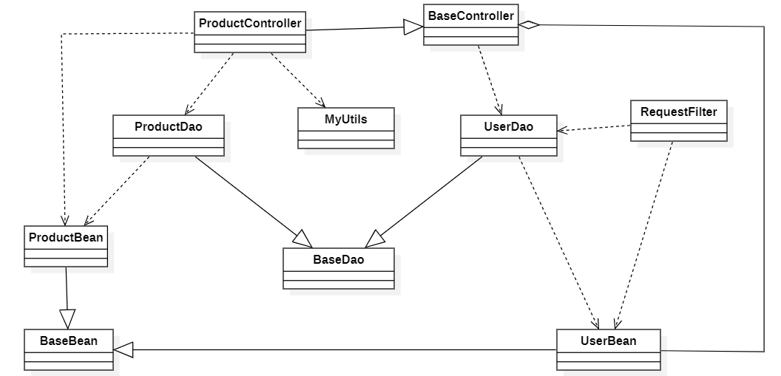
3.1.2 <Sequence Diagram Name1>
[Provide the sequence diagram(s) for the feature, see the sample below]
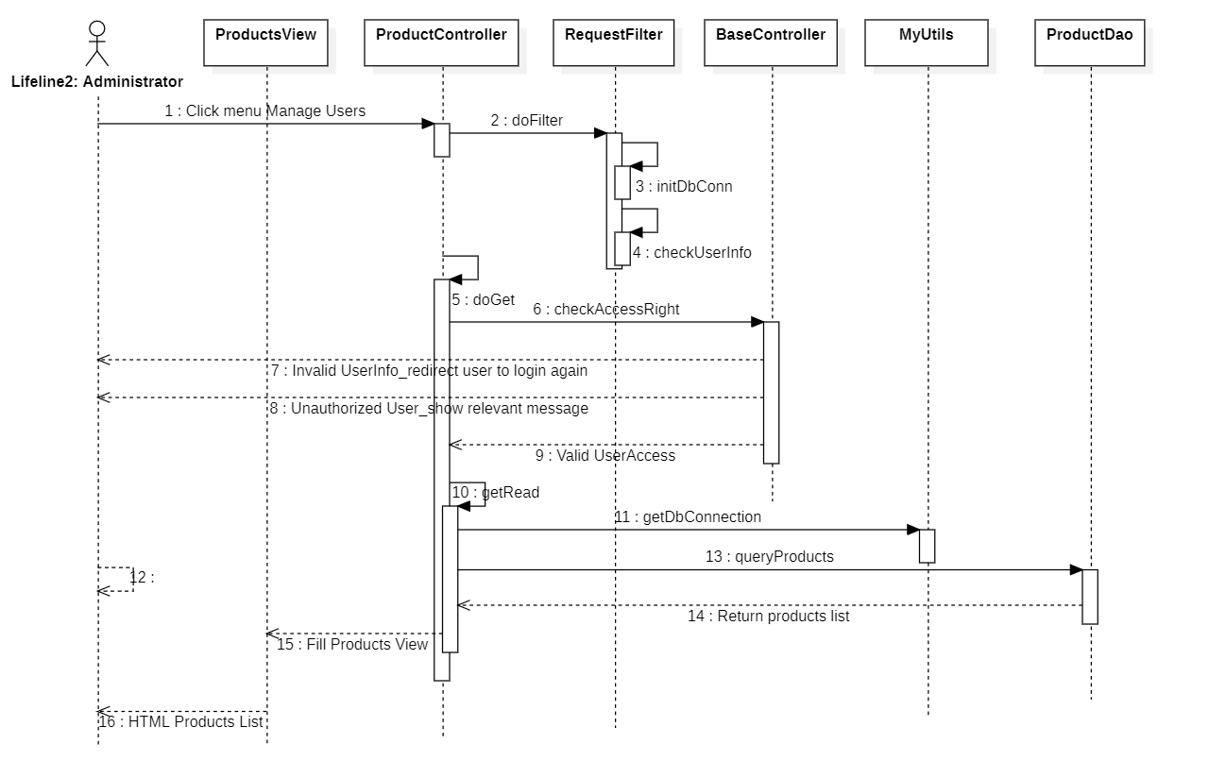

3.1.3 <Sequence Diagram Name2>

3.1.4 …

3.2 <Feature/Function Name2>
…

